KPI’s REQUIREMENTS:

-- Total Customers

SELECT COUNT(*) AS total_cust FROM bank_churn;



-- Total Active customers

SELECT COUNT(isactivemember) AS total_active_cust FROM bank_churn

WHERE isactivemember = 'Yes';

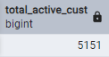

-- Total Exited Customers

SELECT COUNT(exited) AS total_cust_exited FROM bank_churn

WHERE exited = 'Yes';

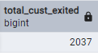

-- Total Customers Exited by each Country

SELECT

Geography,

COUNT(exited) AS total

FROM bank_churn

WHERE exited = 'Yes'

GROUP BY Geography

ORDER BY total DESC;

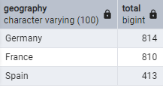

-- Average Tenure

SELECT ROUND(AVG(tenure)::numeric, 2) AS Avg_tenure

FROM bank_churn;

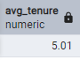

-- Total Number of Customers having Credit Card

SELECT COUNT(hascrcard) AS total

FROM bank_churn

WHERE hascrcard = 'Yes';



-- Average Estimated Salary

SELECT ROUND(AVG(estimatedsalary)::numeric,2) AS avg_estimated_salary

FROM bank_churn;

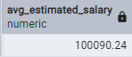

-- See if account balance influences churn

SELECT exited, ROUND(AVG(balance)::numeric,2) AS avg_balance

FROM bank_churn

GROUP BY exited;

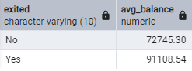

-- Total Active Female Customers

SELECT COUNT(*) AS total_female_cust

FROM bank_churn

WHERE Gender = 'Female' AND isactivemember = 'Yes';

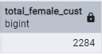

-- Total Active Male Customers

SELECT COUNT(*) AS total_male_cust

FROM bank_churn

WHERE Gender = 'Male' AND isactivemember = 'Yes';

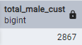

-- Average Credit score

SELECT ROUND(AVG(creditscore)::numeric,0) AS avg_creditscore

FROM bank_churn;



-- Find customers who left the bank within the first few years

SELECT customerid, surname, tenure, balance

FROM bank_churn

WHERE exited = 'Yes'

AND tenure <= 2

ORDER BY tenure ASC;

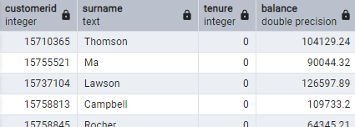

-- Check if low credit scores lead to higher churn.

SELECT

CASE

WHEN creditscore < 400 THEN 'Very Low (0-399)'

WHEN creditscore BETWEEN 400 AND 599 THEN 'Low (400-599)'

WHEN creditscore BETWEEN 600 AND 799 THEN 'Medium (600-799)'

ELSE 'High (800-1000)'

END AS credit_score_category,

COUNT(*) AS total_customers,

COUNT(CASE WHEN exited = 'Yes' THEN 1 END) AS churned_customers,

ROUND(COUNT(CASE WHEN exited = 'Yes' THEN 1 END) * 100.0 / COUNT(*),2) AS churn_rate

FROM bank_churn

GROUP BY credit_score_category

ORDER BY churn_rate DESC;

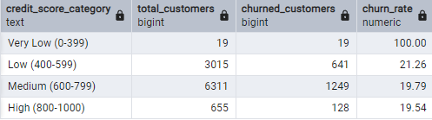

-- Find customers with low balance & low credit scores who are likely to churn.

SELECT customerid, surname, balance, creditscore, tenure

FROM bank_churn

WHERE balance < 5000

AND creditscore < 500

AND exited = 'No' -- They haven't churned yet but are at risk

ORDER BY creditscore ASC;

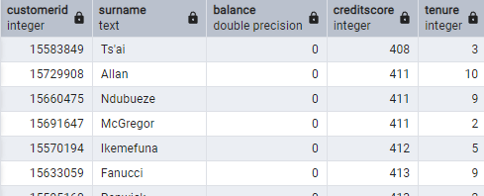

-- Identify customers with high balances who still churned (important for retention strategy).

SELECT customerid, surname, balance, creditscore, tenure

FROM bank_churn

WHERE exited = 'Yes'

AND balance > 100000

ORDER BY balance DESC;

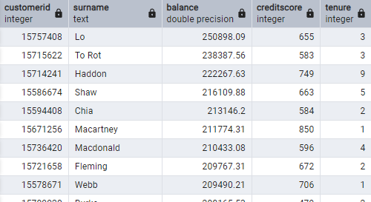

-- Group customers by age brackets to see which age group churns the most.

SELECT

CASE

WHEN age < 25 THEN 'Under 25'

WHEN age BETWEEN 25 AND 40 THEN '25-40'

WHEN age BETWEEN 41 AND 60 THEN '41-60'

ELSE 'Above 60'

END AS age_group,

COUNT(*) AS total_customers,

COUNT(CASE WHEN exited = 'Yes' THEN 1 END) AS churned_customers,

ROUND(COUNT(CASE WHEN exited = 'Yes' THEN 1 END) * 100.0 / COUNT(*), 2) AS churn_rate

FROM bank_churn

GROUP BY age_group

ORDER BY churn_rate DESC;

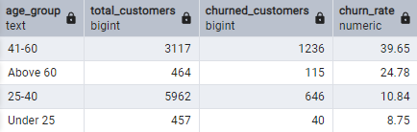

-- Analyse if churn rates differ between male and female customers.

SELECT gender,

COUNT(*) AS total_customers,

COUNT(CASE WHEN exited = 'Yes' THEN 1 END) AS churned_customers,

ROUND(COUNT(CASE WHEN exited = 'Yes' THEN 1 END) * 100.0 / COUNT(*),2) AS churn_rate

FROM bank_churn

GROUP BY gender;

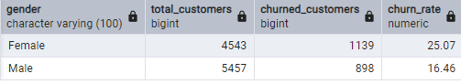

--- END ---